Module 9 Discussion
There are many options for reporting bugs. The solution level should match the application or module we are requesting to be reported. For many small programs with a specific target audience, we could probably get away with a simple bug form like an IT ticket. The user would need to submit:
- The date they encountered the bug
- A description of the issue they faced (as detailed yet as concise as possible)
- And any information about the software configurations they were using (this can be important, as user configurations can cause issues with bugs)
- Information about the person submitting the bug, so the development team can get back to them with questions if needed.
On the back end, our Quality team would then need to assign a severity level to the bug using a numerical scale or more descriptive terms and assign it to a developer or development team to resolve.
For larger applications with a large user base, especially those targeting the general public rather than an internal system, there are many types of software available to assist with this process. Jira and Bugzilla are widely known and used quite frequently by development teams. They automate much of the process of generating bug reports and can ask users questions to dig deeper into the issues that cause them. Some will even allow you to upload screenshots and screen capture videos to make it easier for development teams to see what is going on and duplicate the bug, so they know what actually needs patching.

For an in-house system, a spreadsheet would probably suffice in tracking bugs. A database seems like a little bit of overkill for smaller systems, but it could work as well (and give better control over access than a spreadsheet).
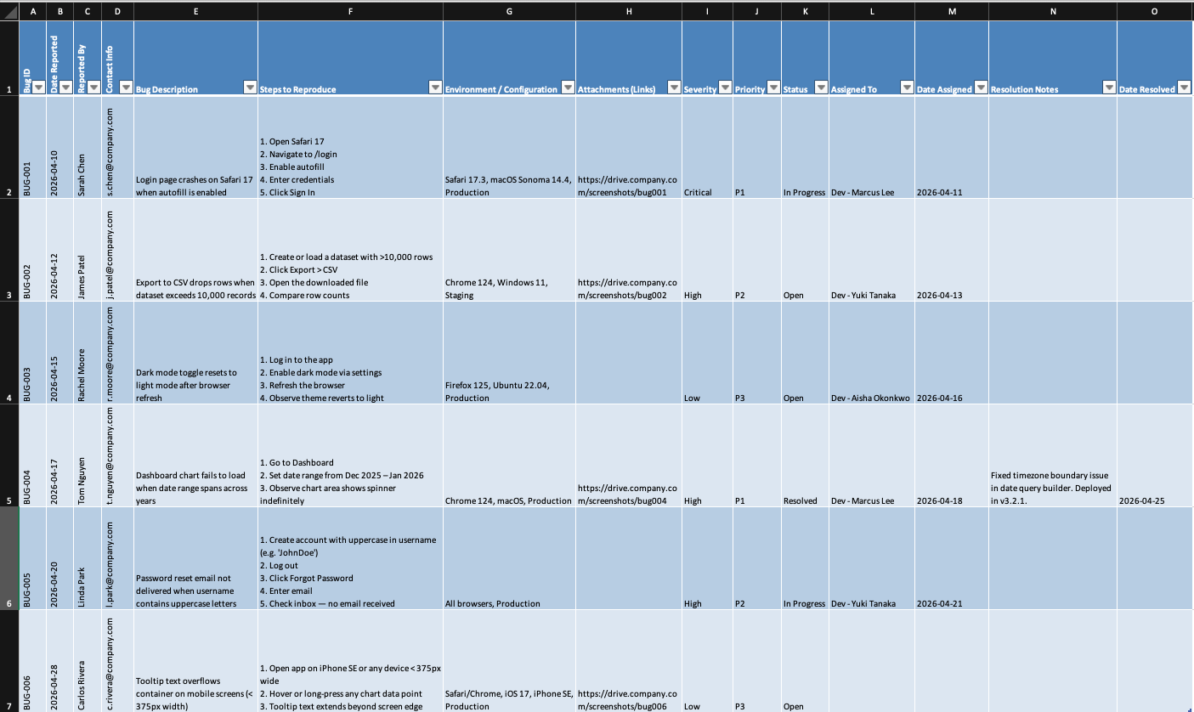
(This report was structured by me, but the data for the bugs was generated by ChatGPT (OpenAI, 2026).)

A system will have a much more in-depth and user-friendly dashboard for us to use. Here is an example from Bugzilla.
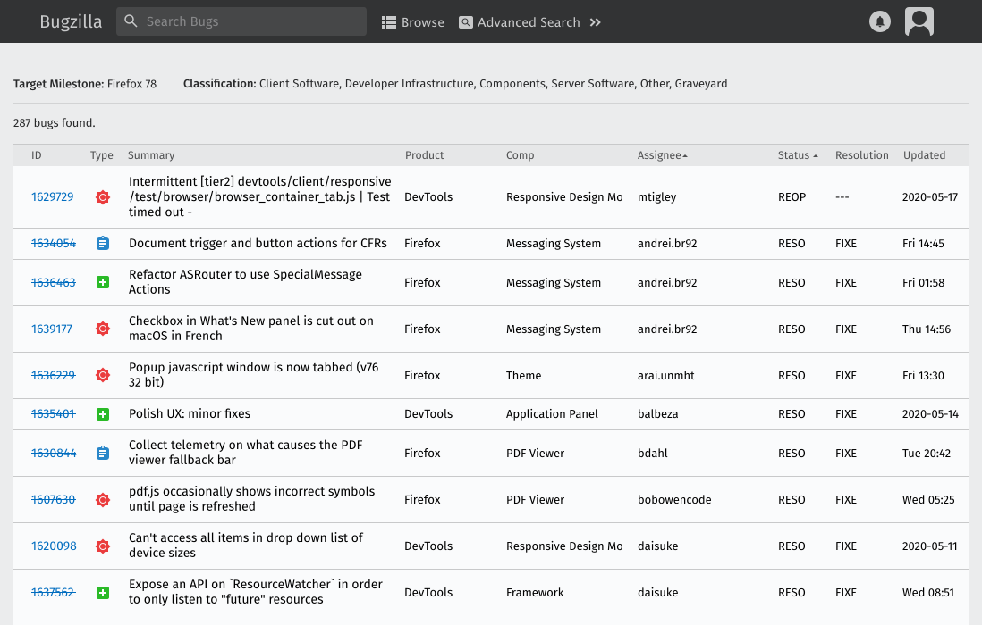

In conclusion, it really depends on how many users the application will have and which route we want to take. An in-house program will save us money and is very practical for small-scale applications. However, for larger, more public applications, a more robust bug-tracking software may be appropriate.
References
Atlassian. (n.d.). Bug triage.
https://www.atlassian.com/agile/software-development/bug-triage
Atlassian. (n.d.). Bug reporting tools: How to write better bug reports.
https://www.atlassian.com/blog/loom/bug-reporting-tools
Bugzilla Project. (n.d.). Screenshot of milestone interface [Screenshot]. https://www.bugzilla.org/assets/img/screenshot-milestone.svg
Mozilla Foundation. (n.d.). Bug writing guidelines.
https://bugzilla.mozilla.org/page.cgi?id=bug-writing.html
OpenAI. (2026, May 4). ChatGPT (GPT-5.3) [Large language model]. https://chat.openai.com/

